 Name___________________

Let’s Learn the 50 States

Activity #1: After listening to the song, “Let’s Learn the 50 States,” try solving as many “Stately” word puzzles as you can. 5 Min. = Master 10 Min. = Good 15 Min. = Study.

A __ __ B __ __ __ and __ __ A __ K __,

A __ __ __ O __ __, __ R __ __ __ S __ __,

__ __ __ I __ __ __ N __ A, C __ L __ __ __ D __,

__ __ N __ __ C __ __ C __ T, and that's not all…

Where, Oh where is __ E __ __ W __ __ E?

It's on the East Coast, our first state, now you've got the first eight!

F __ __ __ __ __ A ‘s the next state then __ E O __ __ __ A

and H __ __ __ __I.

Did you know that the next four states all start with "I"?

I __ __ __ O, I __ L I __ __ __ S, I __ __ __ __ N __,

I __ __ __.

Add 2 K's with __ __ N S __ __ and __ __ N __ __ C __ __,

Let’s Learn the 50 States Cont’

but just 1 “L,” that L __ __ I __ I __ __ A ‘s lucky.

16 states start with M or N,

M __ __ __ E, __ __ R __ __ __ N __,

M __ __ __ __ __ H __ __ __ __ T S,

__ I __ H __ G __ __.

I f you know the next 4 you get a banana,

M __ __ __ E __ __ T __, __ __ S S __ __ S __ __ P __,

M __ __ S __ __ R __, M __ N T __ __ __ .

Half way done and I'm really proud of "ya"

On to the "N's", N __ __ __ A __ __ A and

__ __ __ A __ A.

Four states with "New," forget them you’re a dork,

__ __ W __ A M __ __ H __ __ __,

__ __ W __ E __ S E __ ,

N __ __ M __ __ __ __ __, __ __ __ __ __ R __

N__ __ T H __ __ R __ __ I __ __,

Let’s Learn the 50 States Cont’

N O __ __ __ D __ __ __ __ A,

Let’s sing the chorus now here we go-a! (Chorus)

3 states all start with "O."

O __ __ O, O __ __ A __ O __ A, O __ E __ O __

Way to go!

A B C D E F G H I J K L M N O

P__ __ __ S __ __ __ A __ __ A !

Q, R __ __ D __ __ S __ __ N __,

S __ __ T H D __ __ O __ __ __ A,

S __ __ T H __ A __ __ __ A.

Are you getting thirsty and want a drink of soda?

Just 9 states on the list, let's do in 3/4 time and you'll get the gist.

__ __ __ N __ __ S __ E, T __ __ A __, __ __ A H,

V __ R __ __ __ __, V __ R __ __ N __ __,

W __ __ H __ __ __ T __ __,

Let’s Learn the 50 States Cont’

Three more W's for you to sing,

W __ S T __ __ R __ __ N __ A,

W __ __ C O __ __ __ __, W __ O __ __ N __.
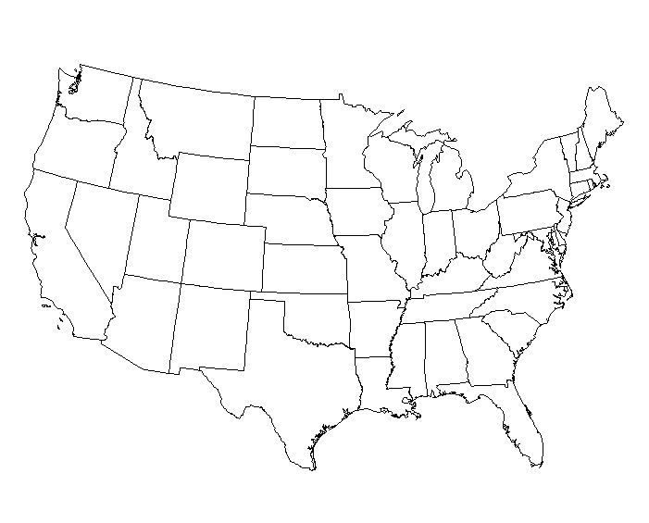
Activity #2:
Visit http://www.teacherandtherockbots.com/games.html to play 50 States “Hangbot.” Based on the popular game, “Hangman.”

“Let’s Learn the 50 States” Answer Key

A L A B A M A and A L A S K A,

A R I Z O N A, A R K A N S AS,

C A L I F O R N I A, C O L O R A D O,

C O N N E C T I C U T, and that's not all…

Where, Oh where is D E L A W A R E?

It's on the East Coast, our first state, now you've got the first eight!

F L O R I D A ‘s the next state then G E O R G I A

and H A W A I I.

Did you know that the next four states all start with "I"?

I D A H O, I L L I N O I S, I N D I A N A,

I O W A.

Add 2 K's with K A N S A S and K E N T U C K Y,

but just 1 “L,” that L O U I S I A N A ‘s lucky.

16 states start with M or N,

M A I N E, M A R Y L A N D,

M A S S A C H U S E T T S, M I C H I G A N.

Let’s Learn the 50 States Answer Key Cont’

I f you know the next 4 you get a banana,

M I N N E S O T A, M I S S I S S I P P I,

M I S S O U R I, M O N T A N A .

Half way done and I'm really proud of "ya"

On to the "N's", N E B R A S K A and

N E V A D A.

Four states with "New," forget them you’re a dork,

N E W H A M P S H I R E,

N E W J E R S E Y ,

N E W M E X I C O, N E W Y O R K

N O R T H C A R O L I N A,

N O R T H D A K O T A,

Let’s sing the chorus now here we go-a! (Chorus)

3 states all start with "O."

O H I O, O K L A H O M A, O R E G O N

Way to go!

A B C D E F G H I J K L M N O

P E N N S Y L V A N I A !

Let’s Learn the 50 States Answer Key Cont’

Q, R H O D E I S L A N D,

S O U T H C A R O L I N A,

S O U T H D A K O T A.

Are you getting thirsty and want a drink of soda?

Just 9 states on the list, let's do in 3/4 time and you'll get the gist.

T E N N E S S E E, T E X A S, U T A H,

V E R M O N T, V I R G I N I A,

W A S H I N G T O N,

Three more W's for you to sing,

W E S T V I R G I N I A,

W I S C O N S I N, W Y O M I N G.

