 Name __________________

Symbols of America

Directions: Cut along the lines of the cards. Turn the cards face down. Each player takes a turn turning over 2 cards to match the clues from the song “Symbols of America” to the picture of that symbol. If no match is made, player returns the cards, face down, and it’s the next player’s turn. The player with the most matches wins the game.

(Suggestion: make copies on cardstock paper)

It's a symbol of freedom that rings E-flat. If you visit Philadelphia, that's where it's at. Mostly made of copper, cast in 1752, weighs more than a ton, has a crack that can't be glued. It hasn't rang since 1835. | 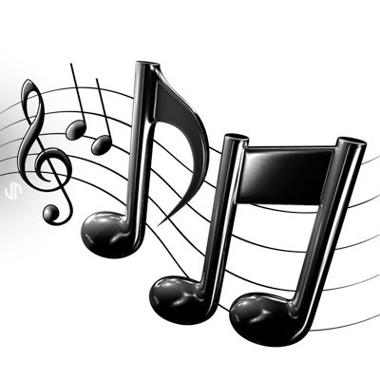  THE NATIONAL ANTHEM
Another symbol flying high and free,  it's on the list of endangered species. But they're being protected and there are more each year,  it's not really bald; there are white feathers there. It's not a turkey like Ben Franklin suggested. | THE BALD EAGLE  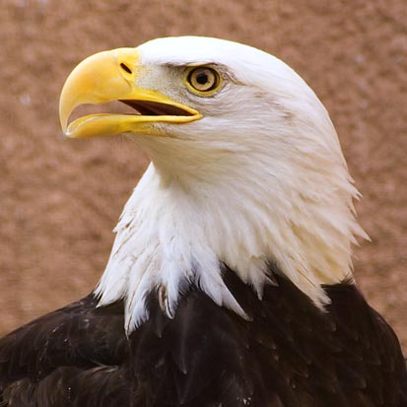

Symbols of America Cont’

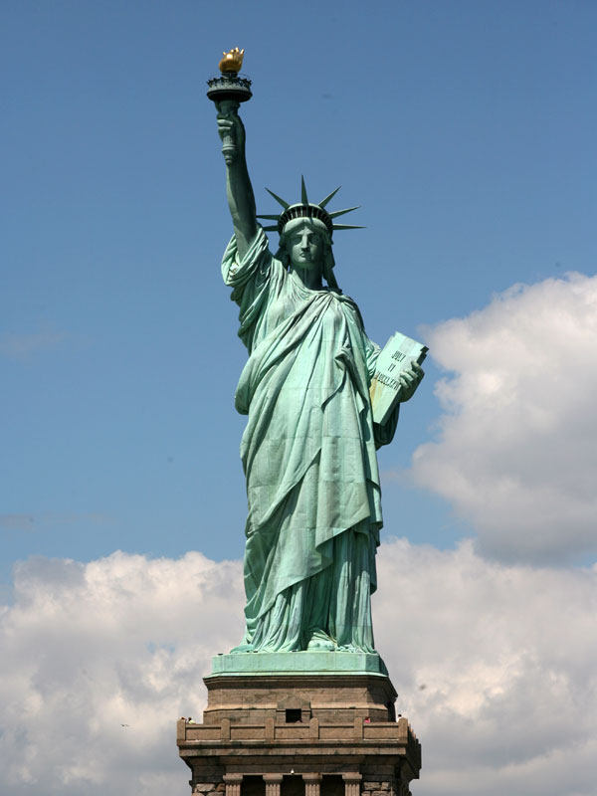  THE STATUE OF LIBERTY | It arrived in New York City in 350 separate pieces in the year  1885. It was a gift from France to America to honor their friendship during the American Revolution. The 25 windows in the crown symbolize gemstones found on earth and the seven rays of the crown represent the seven continents.
In 1892, our country celebrated the 400th anniversary of Columbus' arrival to America. A minister named Francis Bellamy wrote a Pledge that honored our country for this special celebration. It was printed in a magazine and sent to children everywhere and today, you can hear it each morning in schools. | THE AMERICAN FLAG  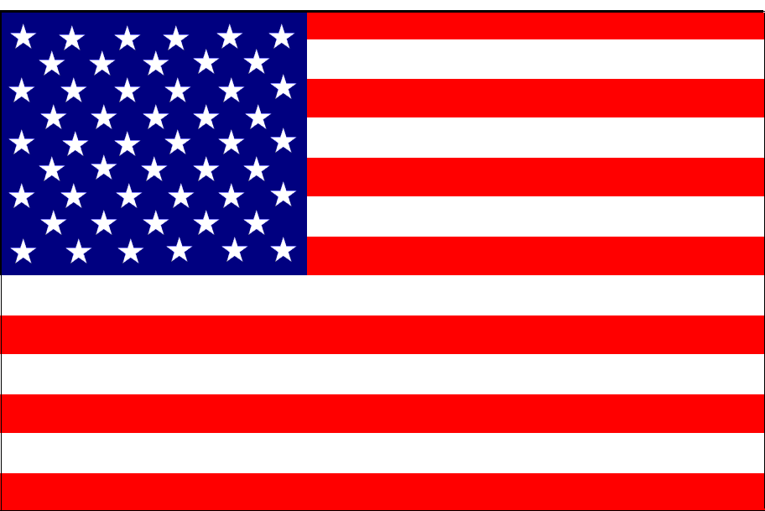
THE LIBERTY BELL  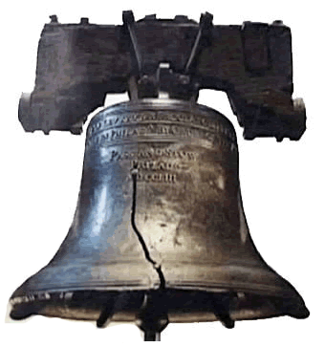 | A poem written by Francis Scott Key,  inspired by a battle with the British he could see. The melody came from a British tune called "To Anacreon in Heaven," but you'll forget that soon!
THE PLEDGE OF ALLEGIANCE | It's changed over time in the part that's blue, adding stars for states as our nation grew. The last star was added in 1960, for Hawaii.  We salute it as it waves in the sky  Rojo, blanco y azul  It's "Old Glory."
Name __________________

Symbols of America

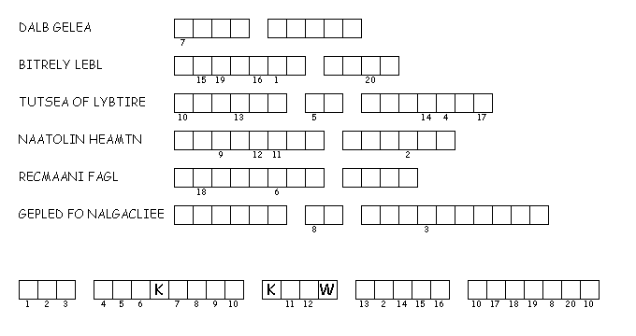
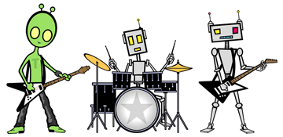
Directions: Unscramble each of the clue words. Copy the letters in the numbered cells to other cells with the same number.

Activity #3: Visit www.teacherandtherockbots.com/games.html to play USA Symbols memory game. Based on the classic game, “Concentration.”

“Symbols of America” Answer Key

A poem written by Francis Scott Key,  inspired by a battle with the British he could see. The melody came from a British tune called "To Anacreon in Heaven," but you'll forget that soon!  . | THE NATIONAL ANTHEM
Another symbol flying high and free,  it's on the list of endangered species. But they're being protected and there are more each year,  it's not really bald; there are white feathers there. It's not a turkey like Ben Franklin suggested. | THE BALD EAGLE

THE STATUE OF LIBERTY | It arrived in New York City in 350 separate pieces in the year  1885. It was a gift from France to America to honor their friendship during the American Revolution. The 25 windows in the crown symbolize gemstones found on earth and the seven rays of the crown represent the seven continents.
It's changed over time in the part that's blue, adding stars for states as our nation grew. The last star was added in 1960, for Hawaii.  We salute it as it waves in the sky  Rojo, blanco y azul  It's "Old Glory." | THE AMERICAN FLAG
THE LIBERTY BELL | It's a symbol of freedom that rings E-flat. If you visit Philadelphia, that's where it's at. Mostly made of copper, cast in 1752, weighs more than a ton, has a crack that can't be glued. It hasn't rang since 1835
THE PLEDGE OF ALLEGIANCE | In 1892, our country celebrated the 400th anniversary of Columbus' arrival to America. A minister named Francis Bellamy wrote a Pledge that honored our country for this special celebration. It was printed in a magazine and sent to children everywhere and today, you can hear it each morning in schools.

