 Name __________________

The National Anthem

Directions: In the song “The National Anthem”, Teacher and the Rockbots offer their explanation to the words of The National Anthem. Below, write your own explanation and draw a picture to show your explanation.

Actual Lyrics | Teacher and the Rockbots’ Explanation | Student Explanation | Picture of what the words mean
O say, can you see, by the dawn's early light,  What so proudly we hail'd at the twilight's last gleaming? | That's an old-fashioned, super-dramatic way to ask if anyone could tell what had happened in the previous night's battle

The National Anthem Cont’

Whose broad stripes and bright stars, thro' the perilous fight,  O'er the ramparts we watch'd, were so gallantly streaming? | Francis Scott Key was watching from a safe distance to see if the American flag was still flying over the Fort
And the rockets' red glare, the bombs bursting in air,  Gave proof thro' the night that our flag was still there. | Flashes of light from constant explosions allowed everyone to see that Fort McHenry had not been captured by the British

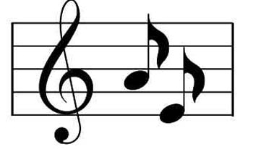

“The National Anthem” Answer Key

Due to the interpretive nature of these questions, there are no “right” or “wrong” answers, only answered and unanswered explanations.

Possible special activity:

Collect the explanations and try to put together the best interpretation of the anthem possible using only students’ work. Read aloud the final “interpretation.” Have the students discuss why their version is better or worse than Francis Scott Key’s or the Rockbots’.

