 Name __________________

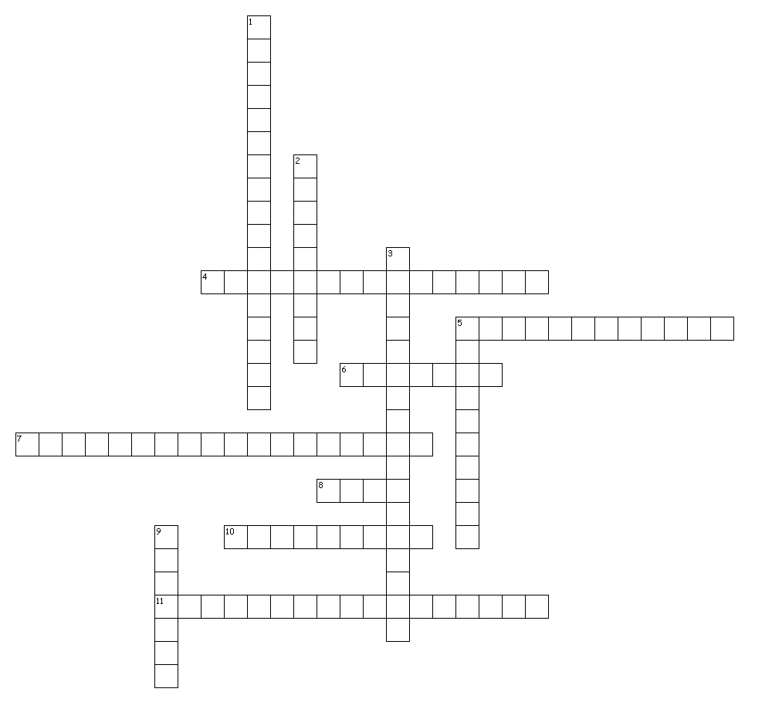
Directions: Use the clues on the next page to fill in the puzzle. The word bank may help you!
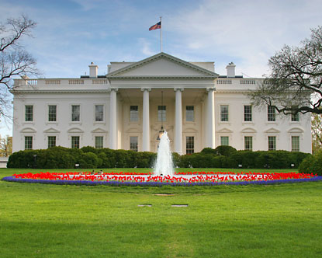
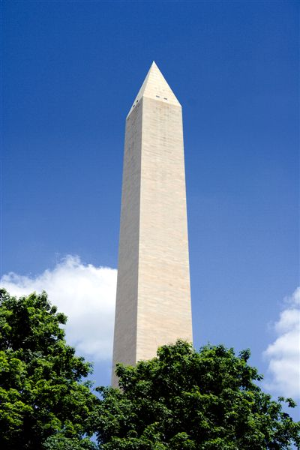
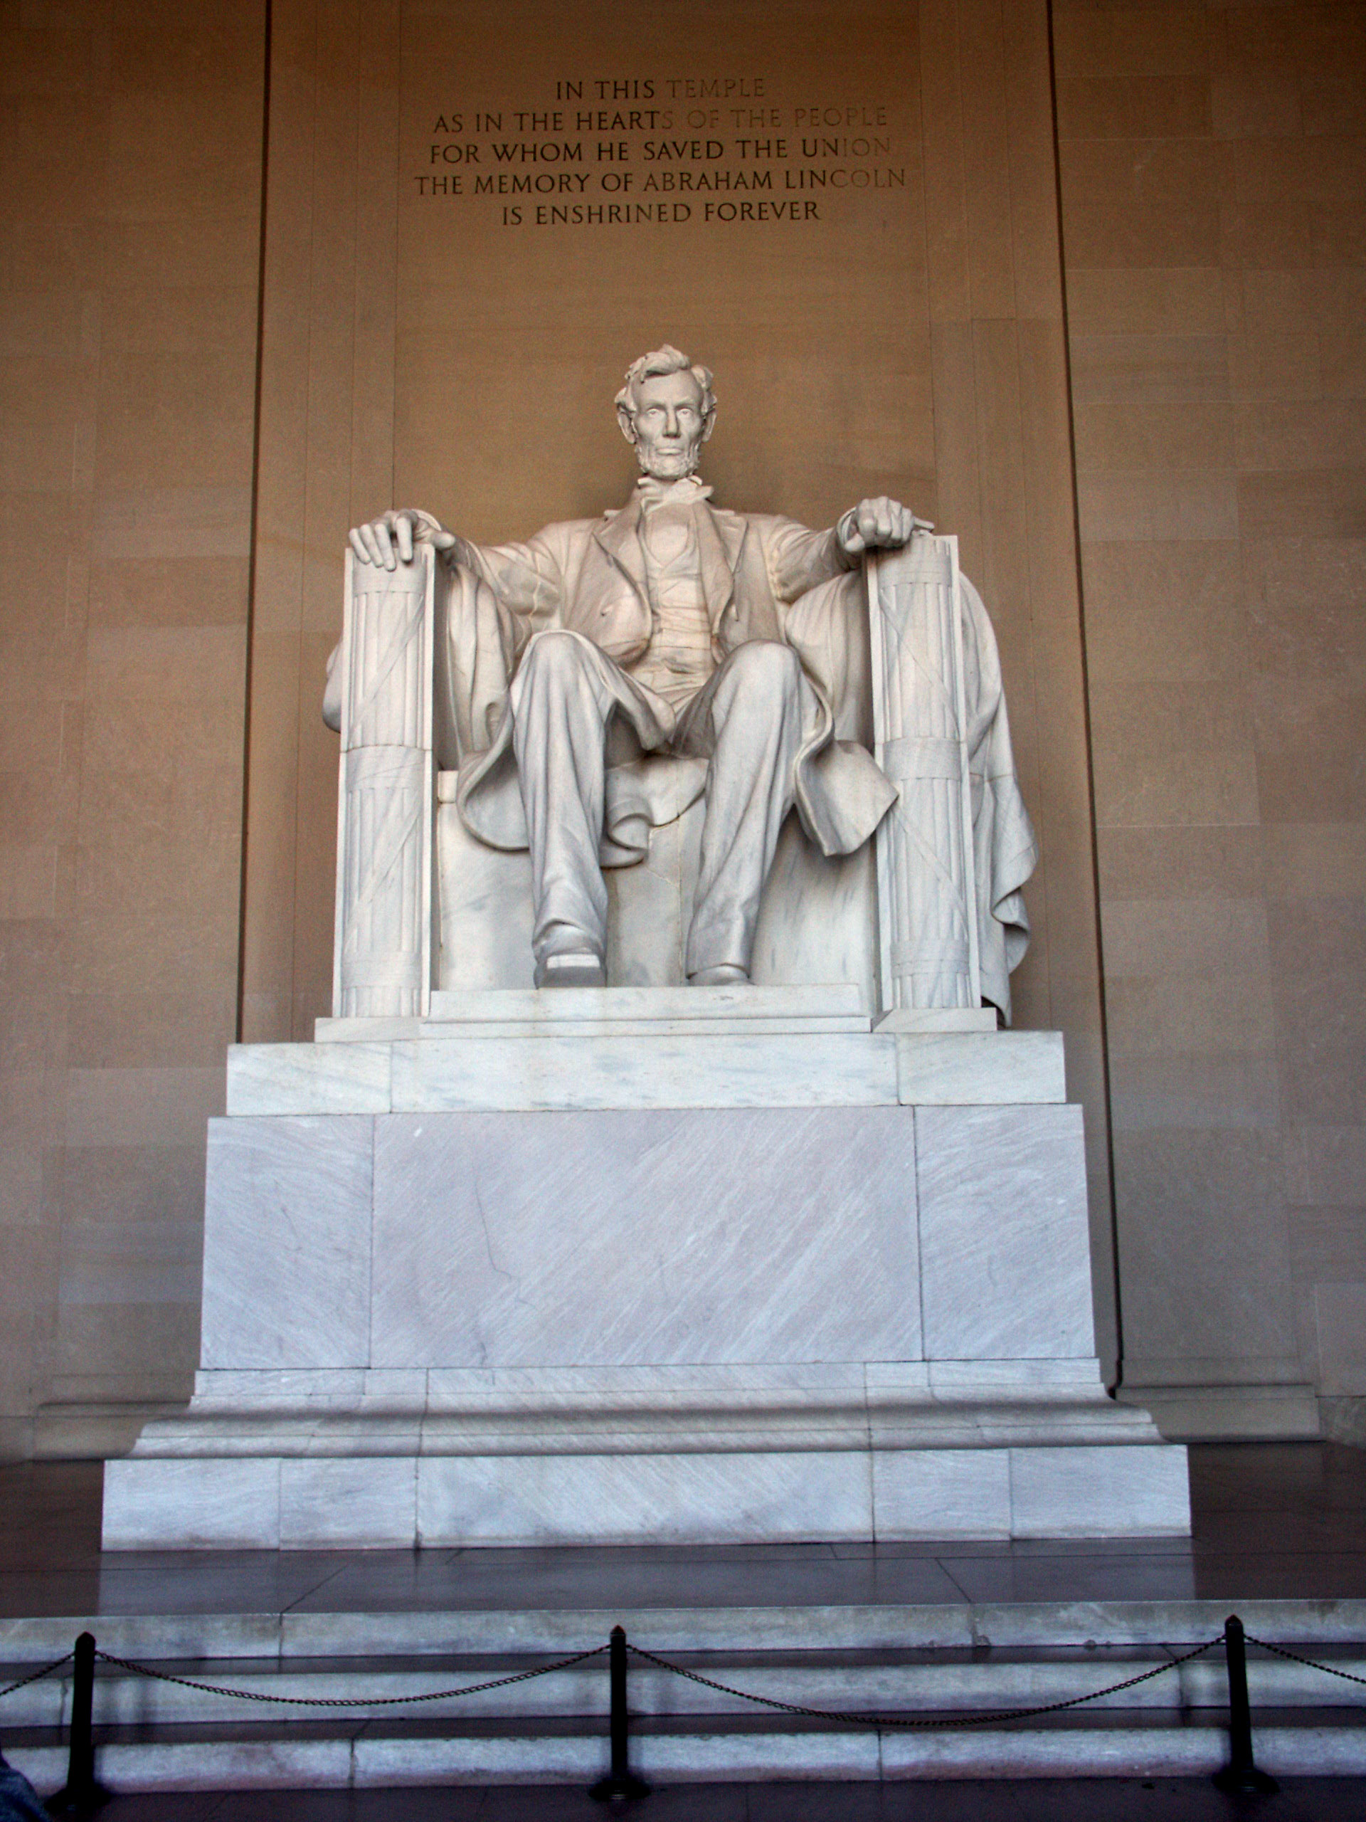

Across
4. Our 16th President is honored here
5. Our nations capitol
6. The top of the Washington Monument is shaped like a
__________.
7. It’s 555 feet tall
8. The roof of the capitol building is a ________________.
10. It’s where the Senate and House of Representatives meet
11. This speech is carved on the wall of the Lincoln memorial

Down
1. It’s where the Congress goes when they need research done
2. The White House has 35 of these
3. This monument honors our 3rd President
5. Every President’s lived there except George Washington
9. The Library of Congress is the __________ of these in the
world.

Word Bank
Jefferson Memorial White House
Lincoln Memorial US Capitol
Washington Monument Washington D.C.
Bathrooms Pyramid
Dome Largest
Gettysburg Address Library of Congress

