 Name __________________

Five Holes In My Head

Directions: In the box by each set of pictures, write a multiplication number sentence that will tell you how many holes are in each group’s heads. The first one has been done for you.

I like the number five.
It reminds me of the holes in my head.
When I've got to multiply,
I think about the holes in my head.
(Two ears + two nostrils + one mouth = five holes)

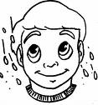

1 x 5 = 5

ME



____ x ____=____

ME ED

Five Holes In My Head Cont’


____ x ____=____

ME ED FRED
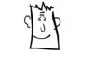

____x____=____

ME ED FRED JED


ME ED FRED JED RED

____x____=____



ME ED FRED JED RED TED

____x____=____

Five Holes In My Head Cont’
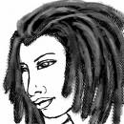

ME ED FRED JED RED TED NED

____x____=____

ME ED FRED JED RED TED NED
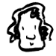

____x____=____

AUNTY MILDRED
ME ED FRED JED RED TED NED


____x____=____

AUNTY MILDRED WINSTEAD

“Five Holes In My Head” Answer Key

1 x 5 = 5

2 x 5 = 10

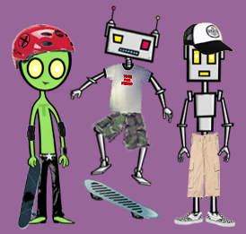
3 x 5 = 15

4 x 5 = 20

5 x 5 = 25

6 x 5 = 30

7 x 5 = 35

8 x 5 = 40

9 x 5 = 45

