 Name __________________

One is Like a Copy Machine
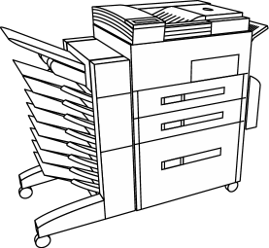
To multiply by one is such an interesting thing.
It's a little like using a copy machine.
You'll get back a picture of what you put in.
It mirrors the image of most anything.

Directions: Solve the problems below.

1 x 1 = _____ 2 x 1 = _____ 3 x 1 = _____

4 x 1 = _____ 5 x 1 = _____ 6 x 1 = _____

7 x 1 = _____ 8 x 1 = _____ 9 x 1 = _____

10 x 1 = _____ 11 x 1 = _____ 12 x 1 = _____

BONUS: Use what you know about multiplying by 1 to help you solve the problems below.

1,000 x 1 = _______ 250 x 1 _______

400 x 1 = _______ 35,292 x 1 __________

“One is Like a Copy Machine” Answer Key

Directions: Solve the problems below.

1 x 1 = __1__ 2 x 1 = __2__ 3 x 1 = __3__

4 x 1 = __4__ 5 x 1 = __5__ 6 x 1 = __6__

7 x 1 = __7__ 8 x 1 = __8__ 9 x 1 = __9__

10 x 1 = __10__ 11 x 1 = __11__ 12 x 1 = __12__

BONUS: Use what you know about multiplying by 1 to help you solve the problems below.

1,000 x 1 = __1,000__ 250 x 1 = _250__

400 x 1 = __200__ 35,292 x 1 = _35,292_

