 Name __________________

Animals Belong in Class

Directions: Using the information from the word bank, finish completing the T-Chart below.

Animal Classification

Mammals - Covered with hair

- __________________________________

- Warm-blooded

- Sweat when it’s hot

__________ - __________________________________

- Hatched from hard-shelled eggs

- Migrate with the weather

Fish - __________________________________

- Fins and scales
Animals Belong in Class Cont’

Animal Classification

__________ - Scaly skin

- ________________________________

- Born on land

- Snakes, turtles and crocodiles

__________ - Gills become lungs

- __________________________________

- Born in the water

Arthropods - __________________________________

- Segmented bodies

- __________________________________

Animals Belong in Class Cont’

Word Bank
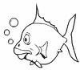
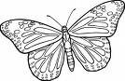

Exoskeleton

Covered with feathers

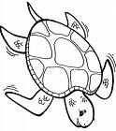
Breathe under water with gills
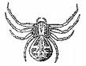
Birds

Can live on land or water

Cold-blooded

Spiders, insects and crabs

Babies drink milk
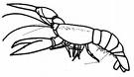
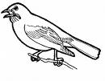
Reptiles

Amphibians

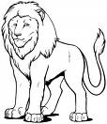

“Animals Belong in Class” Answer Key

Animal Classification

Mammals - Covered with hair

- BABIES DRINK MILK

- Warm-blooded

- Sweat when it’s hot

BIRDS - COVERED WITH FEATHERS

- Hatched from hard-shelled eggs

- Migrate with the weather

Fish - BREATHE UNDER WATER WITH GILLS

- Fins and scales
“Animals Belong in Class” Answer Key Cont’

Animal Classification

REPTILES - Scaly skin

- COLD-BLOODED

- Born on land

- Snakes, turtles and crocodiles

AMPHIPIANS - Gills become lungs

- CAN LIVE ON LAND OR WATER

- Born in the water

Arthropods - EXOSKELETON

- Segmented bodies

- SPIDERS, INSECTS AND CRABS

