 Name __________________

Simple Machines

Directions: Cut out the pictures on the next page. Glue them under the correct label.

LEVER | INCLINED PLANE | WEDGE
SCREW | WHEEL and AXLE | PULLEY

Simple Machines Cont’

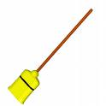 | 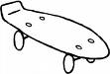 | 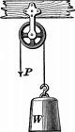
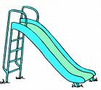 |  | 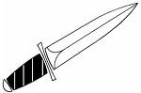
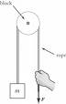 |  | 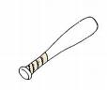
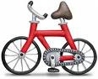 | 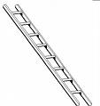 | 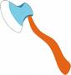
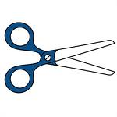

“Simple Machines” Answer Key

LEVER | INCLINED PLANE | WEDGE
SCREW | WHEEL and AXLE | PULLEY

