 Name __________________

Where Will I Go? (Digestive System)

Directions: Use the word bank to help label the parts of the digestive system.

Word Bank
Large Intestine Small Intestine Stomach
Rectum Esophagus Mouth

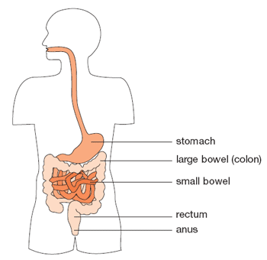

“Where Will I Go?” (Digestive System) Answer Key
Stomach
Small Intestine
Rectum

Mouth

Esophagus

Large Intestine

