 Name __________________

Cities, States, Countries & Continents

Directions: Read each description below. Write the word City, State, Country or Continent depending on which best identifies the description.

___________ A place full of neighborhoods.

___________ A group of countries that come together.

___________ This is formed when a bunch of states come
together.

___________ A large collection of cities.

___________ Province, commonwealth and district are other
names for this.

___________ The biggest place you can be from.

___________ Countries are found on this type of land.
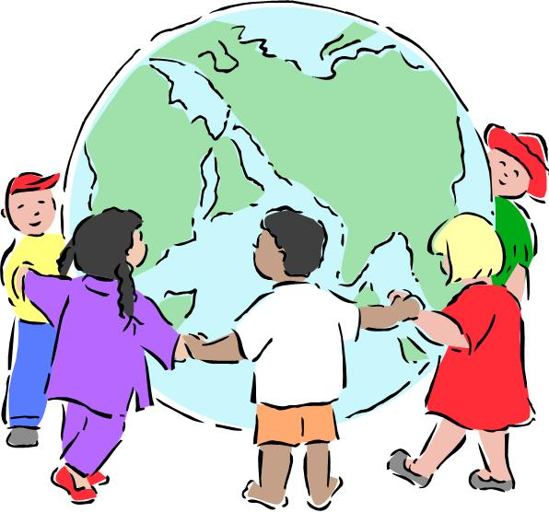

“Cities, States, Countries & Continents” Answer Key

CITY A place full of neighborhoods.

CONTINENT A group of countries that come together.

COUNTRY This is formed when a bunch of states come
together.

STATE A large collection of cities.

STATE Province, commonwealth and district are other
names for this.

CONTINENT The biggest place you can be from.

CONTINENT Countries are found on this type of land.

