 Name __________________

Oceans

Directions: Use the clues from the song “Oceans”, to help you locate and label the five oceans.
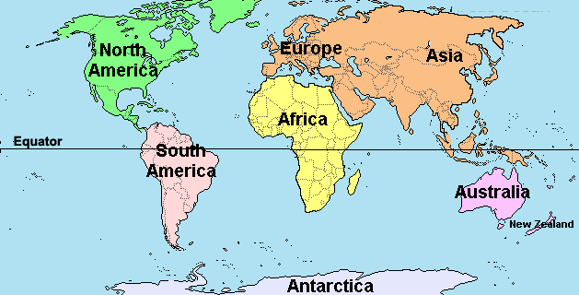

The biggest one lies between America and Asia.
Marianas Trench is the deepest spot;
7 miles from the bottom to the top.
Magellan picked its name because it's peaceful, you know.
Whales swimming in it off the coast of Mexico.
Peaceful...that must be the PACIFIC ocean!

Oceans Cont’

See if you can name the 2nd ocean.
Northern currents keep it in a constant motion.
Lobsters off the coast of Maine are swimming here.
South America and Africa are near.
Columbus sailed across it all the way from Spain.
Do you know this ocean can you tell me its name!
Good thing Columbus wasn't on the Titanic. It sank in the ATLANTIC!
See if you can name this far away ocean.
It was the European's ocean route to Asia.
Vasco De Gamma used to take a boat ride
Around the tip of Africa to the other side.
It's how the Europeans got their silk and spice,
If their boats didn't sink from a Monsoon strike.
The heavy rains from a monsoon are in India. It's the INDIAN ocean!
Here comes another ocean for you to know;
Frozen most of the year at the North Pole.
A walrus and a seal and a penguin in sight;
Winter's always dark, summer's always light.
Icebergs aren't much fun for ships.
Those gigantic ice cubes make the temperature dip.
Well, if it's not the ARCTIC ocean, I don't know what it would be!
You know in the year 2000, the International Hydrographic Organization decided to name a 5th new ocean. It's called the SOUTHERN ocean and it surrounds Antarctica.

“Oceans” Answer Key

Atlantic Ocean
Pacific
Ocean
Indian Ocean
Artic Ocean
Southern Ocean

