 Name __________________

One World (Take Care Of It)

Activity 1

Directions: Unscramble each of the clue words. Copy the letters in the numbered cells to other cells with the same number.
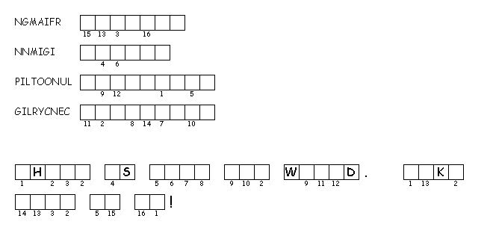
Activity 2

Directions: List some things that you can do to help take care of the world.
1.
2.
3.
4.
